Poultry Health Services Ltd.
201 - 151 East Lake Blvd Rd NE, Airdrie, Alberta T4A 2G1
Telephone: (403) 948-2252; Fax: (403) 948-2285; E-mail: phsinfo@poultryhealth.ca

Sample collection protocol
For the generation of a Fecal Oocyst Shedding Curve

Pre-labeled bags have been prepared for the purposes of sampling.

Direction
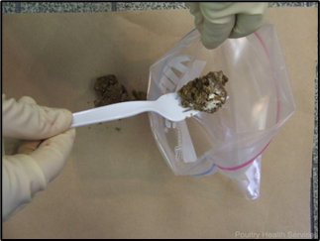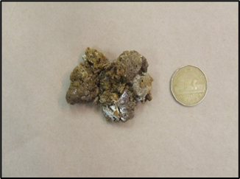
You will need to:

- Collect 10-20 grams fresh fecal droppings, making sure there is as little litter as possible, and place them into one of the pre-labeled bags provided.
- The minimum number of droppings in one sample bag is 10; however, if younger birds are being sampled, more droppings are required to meet the minimum sample mass of 20 grams.
- The droppings should be collected from random locations throughout the barn.
- The droppings collected need to include both fecal droppings (well formed, often have a ‘white cap’) and cecal droppings (tend to be wetter and more caramel colored).

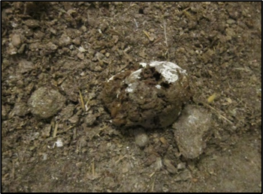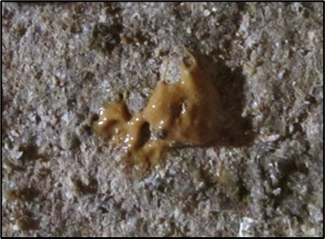
Fecal Dropping Cecal Dropping

Farm Name:
Placement date:
PHS Case #:

Sample schedule:

Age (days) | Date (year 202-)
15
18
21
24
27
30
33
36
Sample storage:
- Collected samples MUST be stored at refrigeration temperature (about 4◦C); samples CANNOT be frozen or left at room temperature.
- All Ziplock bags with feces MUST be compressed to make sure there is no air inside the bag in contact with the samples.
- All collected samples MUST reach the lab for testing within 7-10 days of the collection date.

