A representative sample includes birds showing the signs of disease or concern. Routine mortality such as culls and runts should not be included in the submission, unless they represent the population in question.

Please call our office 403-948-2252 to advise us that shipment is on its way (provide owner name and Purolator Waybill #. Keep a copy of the waybill in the event that it needs to be tracked.
Three Shipping Choices Available
- Send submission via private courier (Purolator). You must package the submission according to these Shipping and Packaging directions. You will be charged for the courier fee.
- Bring submission directly to the Airdrie.
Urgent cases delivered directly to Airdrie will be examined as soon as possible, often within 1 hour.
3. Send submissions via the Government Courier Service, available in Edmonton & Lethbridge.

When delivering to any government office, please: DO NOT DELIVER SUBMISSIONS TO THE RECEPTION AREA
- Proceed to the Reception Area.
- Fill in all of the information requested on the Poultry Submission Sheet, sign and date the form.
- Please alert Reception Staff if your case is an emergency or if you are submitting live birds and require blood samples to be taken.
- Deliver submission to the designated Postmortem Receiving Area.
Shipping and Packaging Requirements
Each kit contains: Other supplies needed:
1. One Box, Styrofoam insulating panels, 1. Absorbent pad or newspaper
2 plastic bags, 2 zip ties 2. Ice pack, if none provided
2. May contain ice pack 3. Extra plastic bag
3. Submission form and Ziploc bag 4. Tape to secure bottom & top of box
4. Waybill

HANDLE BOX ASSEMBLY:
- It is important to fold the bottom of the box correctly. The long end with the 3 short tabs is folded down first.
- The two short sides are then folded down.
- The last long side is folded down, tucking the 2 long tabs into the box.
- It is advisable to tape the bottom of the box for added protection against leakage.
- Place a plastic bag between the box and the Styrofoam to line the box.

LARGER BOX ASSEMBLY:
- Set up the box and tape bottom securely.
- Place a plastic bag between the box and the Styrofoam to line the box.

PACKAGING THE SAMPLE: Please see the following page for illustrated instructions.
Sample size: Chicks/Poults - 30 max. Mature birds (>1kg) - 20 max.

1. Place samples in plastic bag, knot top 2. Place into 2nd plastic bag w/newspaper
3. Zip tie 2nd bag securely 4. Place samples in box w/ice pack
5. Place final Styrofoam panel in the box 6. Securely zip tie plastic box liner
7. Place completed submission form in ziplock bag 8. Tape seams, attach waybill Remember: If your samples leak, you will lose your privilege of using this system. The courier company and Poultry Health Services require that no shipments leak in order to protect our staff and clients.
Shipping Options:
- Drop off submission directly to Airdrie Veterinary Professional Centre: 201-151 East Lake Blvd, NE, T4A2G1Ph: (403) 948-2252
- Drop off submission to Airdrie Agriculture Centre: 97 East Lake Ramp NE, Ph: (403) 948-8577
Submissions will be forwarded to Poultry Health Services in Airdrie.
- Ship to Airdrie via Purolator Courier from nearest agent office. Follow Shipping and Packaging Requirements enclosed.
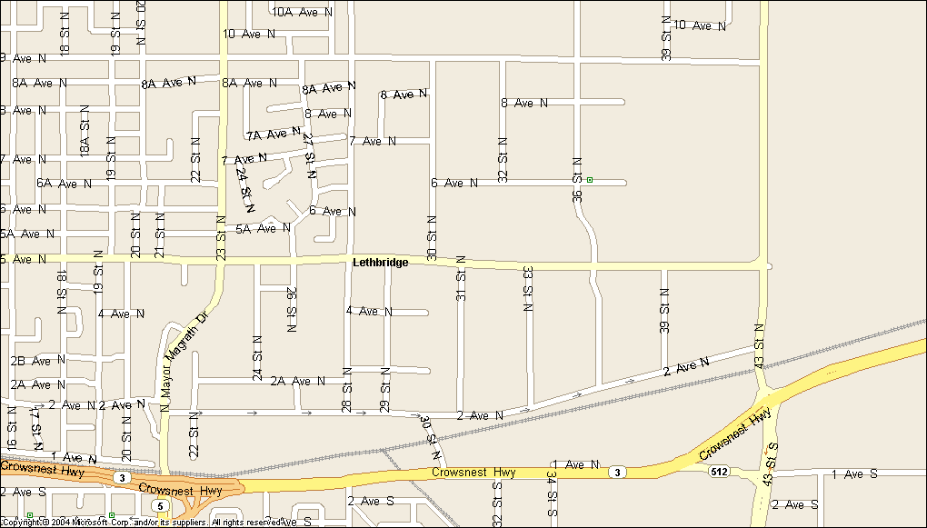
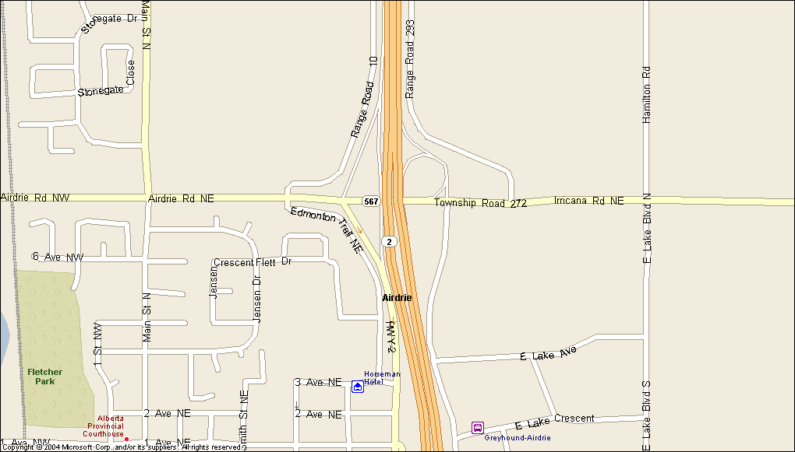
- Submit to Lethbridge, Alberta Agriculture, Food and Rural Development Veterinary Laboratory, 3115 – 5 Ave North, Ph: (403) 381-5190 Submissions will be forwarded to Airdrie. Please contact lab for drop off times to ensure next day delivery
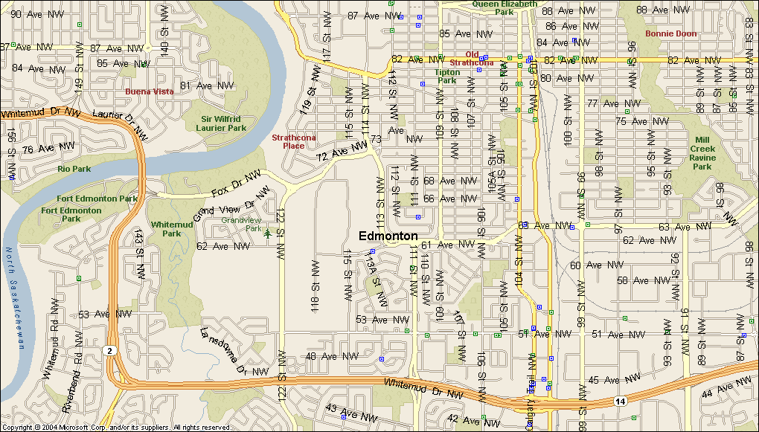
- Submit to Edmonton, Alberta Agriculture, Food and Rural Development, O S Longman Building, 6909 – 116 St., Ph: (780) 422-1923 Submissions will be forwarded to Airdrie. Please contact lab for drop off times to ensure next day delivery

Submissions must be dropped off at the O. S. Longman Building in Edmonton before NOON Monday through Thursday.

Submissions must be dropped off in Lethbridge before 10:30am Monday through Thursday. Submissions received on Friday will be held and shipped the following Monday.

* In case of an Emergency, please contact Poultry Health Services at (403) 948-2252 prior to shipping out samples. *

